Pre-Placement Modules

# Self-enrolment: How to Guide

1. Login to LMS using your Pheme account details (www.lms.uwa.edu.au )
2. Copy the following link and paste it into the URL bar of your browser (<https://lms.uwa.edu.au/ultra/organizations/_35796_1/cl/outline>), then press the **[Return]** key.
3. You should be presented with the following screen. Click on the **“Click here to enrol”** link.

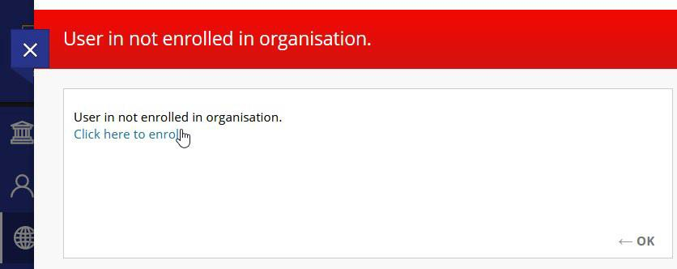

1. Click on the + Enrol link on the left panel of your screen.

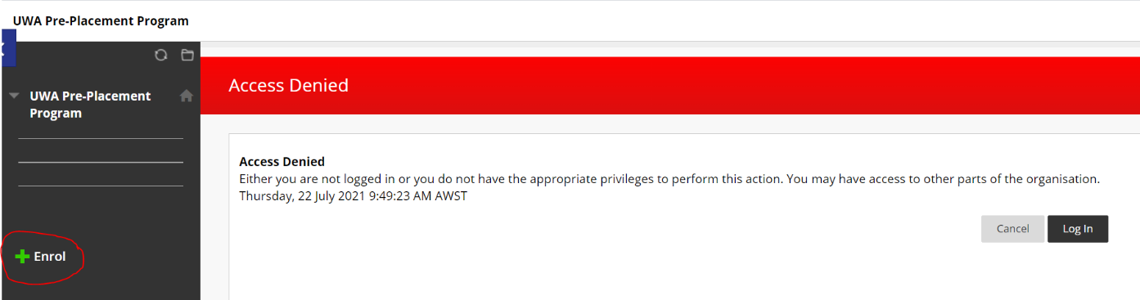

1. From the Self-Enrolment screen, click on the [Submit] button

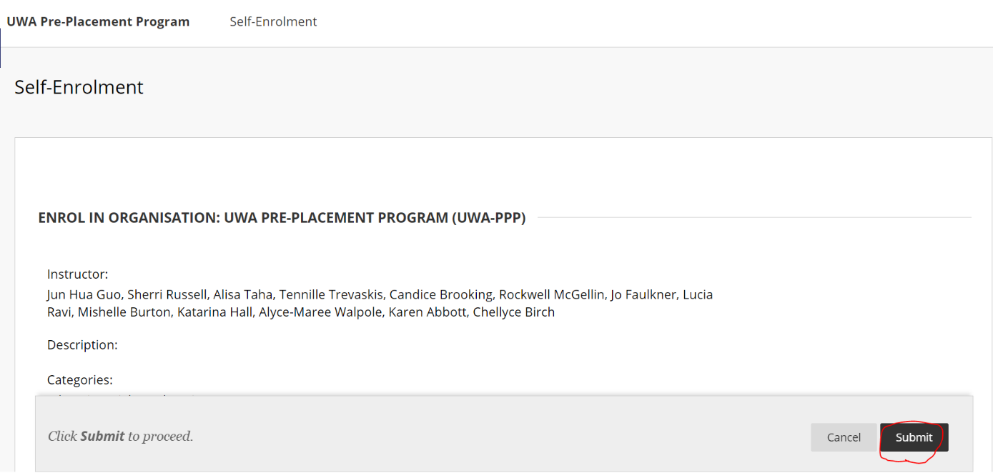

1. The system will provide you with confirmation that your self-enrolment was a success. Click on **[OK]** to be taken to the unit.

